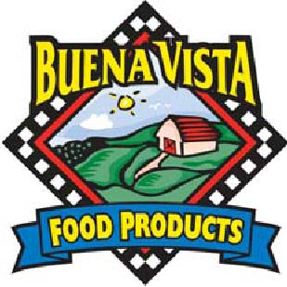

BV RF Three Cheese Calzone, SKU# 50240 (IW) 5.5 oz
BV RF Three Cheese Calzone, SKU# 50230 (B) 5.5 oz

Nutrition Facts | Total Fat 12 g 18% Total Carbohydrate 49 g 16%  Sat Fat 5 g 25% Fiber 2 g 8%  Trans fat 0 g Sugars 4 g  Cholesterol 25 mg 8% Protein 19g  Sodium 610 mg 25%
Amt/Serving size; 5.5 oz
(156 grams)
Servings Size: 1 Calzone
Calories 370
Calories from Fat 110
Vit A – 10% * Vit C – 100% * Calcium – 30% * Iron – 15%

Ingredients:
ENRICHED Flour (Wheat flour, Malted Barley Flour, Niacin, Iron, Thiamin Mononitrate, Riboflavin, Folic Acid), Pizza Sauce (Tomato Puree (water, tomato paste), salt, corn syrup, spices, onion powder, citric acid, xanthan gum, natural flavor), Mozzarella Cheese (Cultured Pasteurized Milk, Salt, Enzymes), Lite Mozzarella Cheese (Pasteurized Part Skim Milk, Nonfat Milk, Cheese Culture, modified corn starch, salt, Vitamin A Palmitate, Enzymes), water, Cheddar Cheese (Cultured Pasteurized Milk, Salt, Enzymes, Coloring If Needed), Provolone Cheese (pasteurized milk, cheese cultures, salt, enzymes), BLEND OF CANOLA AND OLIVE OILS, CONTAINS LESS THAN TWO PER CENT OF: YEAST, SUGAR, Dough Conditioner (Whey, L-Cysteine Hydrochloride), soy lecithin, dextrose, food starch-modified, Rice Flour, Ascorbic Acid, SALT

CONTAINS: Milk, Egg, SOY, WHEAT

Bread Servings: (156 X 0.35)/14.75 = 3.70 Breads (Rounds DOWN to 3.5 Breads)
Meat Alternate Servings: Each calzone contains 2 Servings of Cheese
VEGETABLE SERVINGS: Each Calzone contains 0.37 servings of Tomato sauce (rounds down to 0.25)
Breads | Fruit/Vegetable | Protein
3.5 | .25 | 2.0

I certify that the above information is true and correct.
6/1/2011 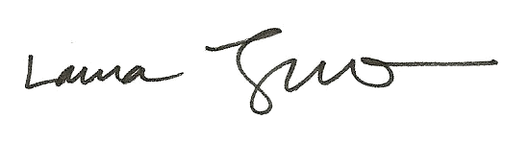
Date Laura Trujillo, RD, SNS

